**Uganda safety on schools** 

# **Background**

 **Safety on schools in BRICE project Uganda**

Safety refers to the wellbeing of all children whether in school or outside school. It entails setting up a system around a child that protects this individual child from any form of harm. It requires knowledgeable and skilled actors in issues of child protection, information on available provisions of the laws and how to apply them. This enhances their active participation and engagement both in and outside school. Actors include school management committees’ administrators, (head) teacher, and parents/guardians.

Schools act as a second home to learners where they learn and unlearn different behavior, cultural practices and beliefs from their peers, teachers and school administrators. A gender responsive school environment should pay attention to the specific needs of each students, providing a conducive learning environment where they interact with people who hold different cultural and religious beliefs.

If some of the behavior and practices learnt are not checked, they can be very harmful and destructive to their lives. Due to the high influx of refugees, teachers who are untrained and unequipped to handle situation with learners from a different contexts and backgrounds, and teacher- student ratios out of control, learning and teaching processes are affected and compromise learning outcomes and safety of the learners. Violence in schools, whether corporal punishment or gendered violence, contributes to cultures of violence and the acceptance of violence as a solution to problems.

**Culture of power**

There are deep-seated cultural and patriarchal norms, power-relations and beliefs that work to create conducive environments and incentives that promote physical, sexual and psychological exploitation against girls and women. Historical legacies of conflict and patriarchal control reinforce the status of the girl as a sexual object to primarily serve the interest of men. Prevailing cultural attitudes and beliefs uphold that women and girls are weak and supposed to submit to men and boys. Girls are perceived as a source of income for the family in form of dowry, so they are easily married off at an earlier age compared to their counter parts. In most communities’ girls’ education is not prioritized and often girls are sent to work in homes of rich people to earn money to support the education of the boy child who is more valuable than the girl.

2 learning topics:

Safety on schools & Technical skills for income generating activities

***Motivation one of the participants Amos***

*Refugees are persistently faced with various humanitarian challenges including school drop out for school age going children, possible discrimination and intolerance by both the host communities and probably amongst refugees themselves of diverse cultural and linguistic background. Mitigation of such challenges requires concerted efforts by all stakeholders. As a teacher educator, I am motivated to participate in this exchange visit as it would present a learning opportunity and enables me gain more experience from other participants in providing a more engaging education strategies and activities aiming at offering second chance to school dropout, restoring hope, promoting co-existence and basic skills to cope with the challenges in the refugees settlement camps.*

***Motivation AVSI participant Calvin*** *With over 10 years working in the Humanitarian Emergency/ Development Response Projects, the emergency intervention has continued to remain increasingly challenging; Youth engagement and Education has remained critical yet seen as opportunity for a long lasting peace / security for many of the conflict affected states. I am motivated therefore to participate in this exchange visit to learn how children and the refugee youth are being engaged in peace building activities in the schools/ community; engagement of parents in the schools management (supporting peace building) and the retention of youth in school to enhance resourceful youth/ adult who will transform their economies and general governance*.

***Motivation Gloria, participant FAWEU****. We are implementing safety nets for learners in schools through clubs and strengthening of community of community structures .More so, FAWEU works to influence positive attitudes towards girl child education; It would be of great value to me to share /learn good practices from other partners in implementing similar activities and apply in Uganda.*

# **Objectives**

To transform fruitful models, knowledge and experiences related to improve safety on schools including technical skills from Kakuma camp in Kenya to the BRICE activities in Uganda.

To strengthen the collaboration of the implementing partners AVSI and FAWE, child protection committees and Oxfam Uganda in BRICE Uganda related to school safety and child protection.

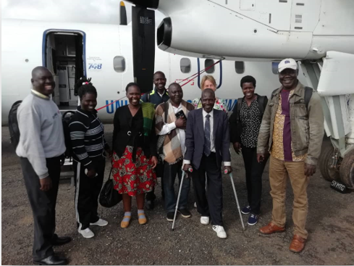

Figure 1 Arrival in Kakuma, start program

# **Composition of the group**

|  |  |  |  |
| --- | --- | --- | --- |
| Oxfam & Partners | Position | Gender | Location |
|  |  |  |  |
| Benedict Lokiru | Global Project manager BRICE | male | Uganda |
| Calvin Opio | Education Project Coordinator  AVSI foundation | male | Uganda |
| Susan Opok | Executive director FAWEU | female | Uganda |
| Auma Gloria | Project Officer- *BRiCE* Project  FAWEU | female | Uganda |
| Amony Janet | Teacher primairy school- AVSI | female | Uganda |
| Okumu Amos Awira | TUTOR-PTC primairy schools | male | Uganda |
| Olara Aggrey | Chairperson CPC - Child protection- committee | male | Uganda |
| Komakech Denis | PTA -teachers representative | male | Uganda |
| Carin Boersma | Facilitator Oxfam Novib | female | Netherlands |

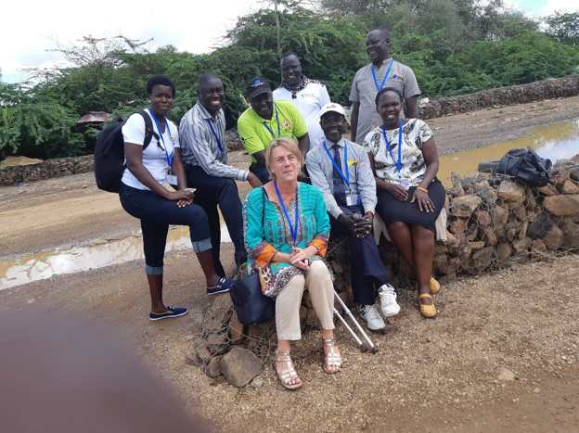

Figure 2 Group photo

# **Key learning outcomes**

* Include social psycho support in AEP curriculum instead of an extra curriculum activity (IRC)
* Strengthen PSS and emotional wellbeing of girls for self actualisation (IRC)
* Training of patrons/ matrons to create (young) men role models as champions for change (IRC)
* Collection of Women’s voices and shared with male champions (IRC)
* VSLA (saving and loan system) training and toolkits for CPCs to create income (IRC)
* Use of remedial classes for slow learners; Grading of learners according to competences; Use of digital data system to monitor enrolment, attendance and performance – follow up ;Use of incentive teachers to teach remedial classes; Use of community mobilizers as contact persons in tracking and making follow up on learners (Windle)
* Formalize club structures in timetables (Windle)
* Youth skilling: Establishment of youth centres supporting digital skills training for youth employability & business enhancement (NRC- RESI)
* Provision of separate classrooms for AEP learners (NRC)

# **The visited organizations and their best practices**

Windle trust International - REMEDIAL EDUCATION PROGRAM - Kakuma camp <https://windle.org.uk/>

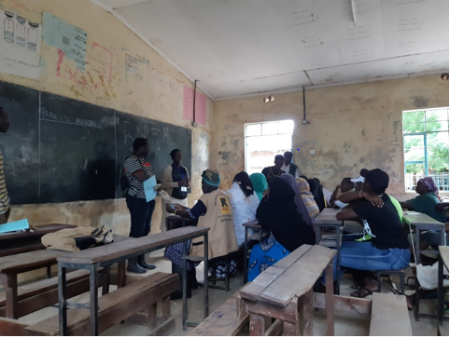

Figure 3 Visit remedial teachers program – Windle

* This education program is based on the theory that “if girls receive additional targeted **education** with specialized and focused support from teachers, they will improve their learning outcomes.” It specifically targets two challenge areas: poor academic performance of girls in refugee areas, and low levels of community support for girls’ education.
* The program is offered to support marginalized girls in refugee and host communities who are filling behind academically, and at the risk of dropping out of school.
* Elements of the Remedial Education Program include the creation of remedial centers, proper identification of at-risk girls, identification and recruitment of teachers and community mobilizers. A combination of remedial centers, appropriately trained teachers, and community mobilizers (who build strong, trusting relationship with families of the girls) ensure the end outcome is not just an increase in overall academic performance, but also psychological empowerment for vulnerable girls.
* More information: <https://static1.squarespace.com/static/583af1fb414fb5b3977b6f89/t/59bdbb4abe42d6f534bc0ad3/1505606477353/1_PromisingPractices_WUSC_WEB.pdf>

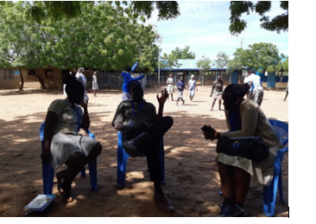

Figure 4 Visit remedial teachers program - Windle

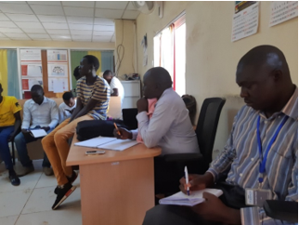

Figure 5 Community mobilisers and incentive teachers - Windle

International Rescue committee - ENGAGING MEN IN ACCOUNTABLE PRACTICES

* One of the major challenges to abolishing school safety is not just about creating a safe space in schools, but also in refugee camps where children and girls spend most of the time. So, this is a community engagement model to involve men in accountable practices leading to a reduction in violence against women, girls, and children in refugee camps.
* Drawing on gender transformative tools, the Engaging Men in Accountable Practices (EMAP) model was developed by International Refugee Council and implemented in cooperation with UNHCR and other actors in Kenya.
* The approach aims to achieve behaviour transformation at the individual level, drawing on an evidence-based, 1 year- long curriculum. The approach targets both women and men, with a special emphasis on men to enable to identify their role in preventing violence against women and become women’s allies.
* This intervention is guided by the voices of women and girls. Their testimony regarding types of violence experienced informs the curriculum used with men. Integral to this implementation is communicating that EMAP activities are not intended to diminish tradition or belief systems, but to encourage practices and beliefs that promote respect for women and non-violence. The intervention is specifically designed for use in humanitarian settings and has been field tested.
* UNHCR rolled out EMAP in Dadaab Refugee Camp in Kenya. The project involved 480 men and women, garnered community interest, and has resulted in positive and transformative outcomes. The safety of women and girls became a central concern for the community, safe spaces for women were created, and participants became highly-regarded and considered as role models in the community. Women reported increased cooperation on household responsibilities by their husbands as well as a positive change in husbands’ attitudes toward violence. In Dadaab, EMAP was also linked to other programs, which resulted in enhanced livelihoods for intervention participants.
* Here are two links to the toolkit for the model:
  + <http://www.fsnnetwork.org/sites/default/files/IRC-EMAP-Introductory-Guide-High-Res%20%281%29.pdf>
  + <http://www.fsnnetwork.org/sites/default/files/EMAP-Implementation-Guide.pdf>

International Rescue committee- GIRLS SHINE PROGRAM

Top of Form

The International Rescue Committee (IRC) is delighted to present *Girl Shine*--a program model and resource package that seeks to support, protect, and empower adolescent girls in humanitarian settings. *Girl Shine* has been designed to help contribute to the improved prevention of and response to violence against adolescent girls in humanitarian settings by providing them with skills and knowledge to identify types of GBV and seek support services if they experience or are at risk of GBV.

The Girl Shine program model and resource package can be used in multiple humanitarian settings, including conflict and natural disasters, as well as within the various phases of emergency response.   It is based on the experience and knowledge gathered through years of IRC’s Women’s Protection and Empowerment efforts to reach adolescent girls in humanitarian settings. It has been adapted to reflect the latest research findings on the experiences of adolescent girls in humanitarian settings, and the nature of GBV against adolescent girls. Girl Shine represents the culmination of IRC’s learning, shaped by research findings, our technical expertise in working with adolescent girls and feedback from adolescent girls we work with and their caregivers.

Included in the resource package are the following:

* Girl Shine: Advancing the field--designing girl-driven gender-based violence programming in Humanitarian settings (Part 1)
* Girl Shine: Life skills curriculum (Part 2)
* Girl Shine: Caregiver curriculum (Part 3)
* Girl Shine: Mentor and facilitator training manual (Part 4)

<https://resourcecentre.savethechildren.net/library/girl-shine>

<https://www.rescue.org/country/kenya>

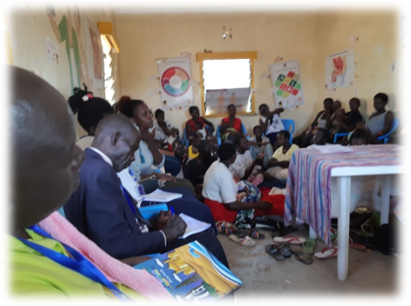

Figure 6 Girls shine project

Norwegian Rescue Council - https://www.nrc.no/

**The Refugee Employment and Skills Initiative (RESI)**

RESI provides trade-led and market-based solutions to foster income generating opportunities for refugees and their hosts, helping build self-reliance and foster economic resilience.

RESI tailors its activities with targeted private and public partnerships, builds strong market connections, and takes capacity building to the next level through relevant network connections, coaching and mentorship. With this approach, RESI ensures newly acquired skillsets translate into actual income gains.

**Challenge the initiative is tackling**

RESI believes there is a pressing need to shift from purely humanitarian or development responses towards more integrated durable solutions, leveraging the expertise and strengths of complementary partners.

According to RESI, Activating the humanitarian-development nexus means bridging the gap between approaches supporting immediate needs in emergency scenarios and those alleviating poverty in the long-term. This collaboration is much needed to support affected populations to become self-reliant and move away from dependence on humanitarian assistance.

Through capacity building, skill upgrading, market linkages, trade opportunities and governmental recognition, targeted populations are provided a set of tools and platforms through which they can become independent.

**Innovation and Solution**

RESI operates through the following two-tier implementation:

1. Promoting the development of commercially valuable skills and market-linkages for refugees and host communities;
2. Supporting local small and medium-sized enterprises (SMEs) to grow and create economic opportunities for displacement affected populations through increased business.

Participant’s acquired skills and connections support their access to sustainable economic opportunities and builds their confidence and independence. RESI harnesses the productive potential of refugees and host community members to respond to the demands of the local economy and eventually support their re-integration in their country of origin if they return home.

Collaboration with multiple actors is a key component of ITC’s approach. RESI works with a diverse range of partners to solve key challenges related to displacement contexts and to build long lasting market connections. RESI engages market partners to harness opportunities for refugees and local communities. This unlocks access to local, regional and global value chains.

RESI innovates with a tailored mentorship and continuous coaching scheme, which complements the training received by refugees and host communities. The mentorship and coaching scheme provides practical guidance and motivational support that helps trainees apply their new skills to manage and overcome challenges they might experience.

<https://www.nrc.no/countries/africa/kenya/>

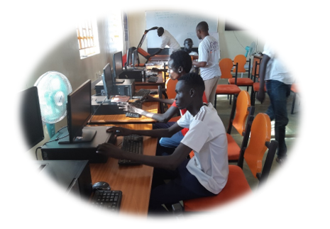

Figure 7 RESI program – NRC

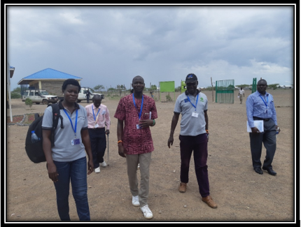

Figure 8 AEP program - NRC

# **Appendix: action plans**

AVSI ACTION POINTS FROM THE LEARNING EXPERIENCE- KAKUMA, KENYA:

|  |  |  |  |  |
| --- | --- | --- | --- | --- |
| **KEY LEARNING from the field** | **KEY ACTION to take home** | **APPLICATION OF ACTION** | **TIME FRAME** | **RESPONSIBILITY** |
| **YOUTH SKILLING (RESI):**  Establishment of youth centres supporting digital skills training for youth employability & business enhancement (RESI) | * Youth identified and trained on freelancing online skills. * Youth trained on ICT business skills. * Youth trained in English language course supporting business communication. * Securing of computer soft wares and trainers (ToT). | * Resource mobilization for digital skills training * Secure trainer * Procure computers * Set a training hall for training- or use AVSI Youth Centre. * Secured internet connectivity * Identification of interested youth for training * Linking of trained youth to business ventures | January, 2020 | PMU &AVSI |
| **AEP – SETUP**  Provision of separate classrooms for AEP learners  Use of remedial classes for slow learners  Grading of learners according to competences  Use of incentive teachers to teach remedial classes  Use of digital data system to monitor enrolment, attendance and performance – follow up  Use of community mobilizers as contact persons in tracking and making follow up on learners. | * Pilot remedial classes for slow learners for L 2&3 * Pilot grading of learners according to competences especially in level 1 * Support the existing teachers to teach remedial classes (some incentive) * Pilot digital data collection system to monitor enrolment, attendance and support follow ups * Mobilize resources for construction of AEP classrooms | * Meet teacher and discuss on the need and piloting of the remedial lessons * Secure instructional materials to support remedial lessons (text books) * Identify learners who need support per centre (L2&3) using the CAM form for now. * Mobilize resources to procure digital data collection application and trainer – Coconut/ COBO- ***Carin*** * Mentor teachers on pedagogy for remedial teaching. * Construct at least 01 classroom block for each of the 3 AEP centres- ***Benedict*** | January, 2020 | PMU& AVSI |

FAWEU ACTION POINTS FROM THE LEARNING EXPERIENCE- KAKUMA, KENYA

|  |  |  |  |
| --- | --- | --- | --- |
| **Projects** | **Benefits/ Strengths** | **Challenges** | **Actions including timeline and budget** |
| **Institution visited International Rescue Committee -IRC** | | | |
| Women’s VSLA (Women Centre 1) | * Support system * Income source for women | * Myths/ attitudes * Poor Leadership * Lack of segregation of duties | * VSLA training for CPCs- FAWEU * Procure VSLA tool kits @ Ushs 300th- need 2 kits (2 gps, @30 mbrs. 7 wks trainings ) |
| Girl Shine | * Empowerment for self actualisation * Pss & creating hope * ASRHR * Prevention rather than response | * Respect for client decision | * Send girls back to formal * ASRH training for girls (jan. 2day training + advocacy in schools)   (materials from Gladys- Carin   * Strengthen pss and emotional wellbeing of girls for self actualisation * Baby care centre (AVSI) * Parenting skills (AVSI) |
| SGBV response | * One stop centre- assessment, response & treatment * Pss * Forensic evidence and representation * Confidentiality/ listening sessions with girls * Self-transformation |  | * One stop centre for SGBV |
| EMAP (Engaging Men through accountable practices to end SGBV) | * Passion (identification) * +ve motivation for change * Appreciate that change is gradual * Undertaken in recognition of 16 days of activism * Collection of women’s voices * Challenge –ve norms * Requires pro-activeness * Creates gender equity | * Victimisation * Negative cultural practices | * Training of patrons/ matrons of child clubs- 2day training. Review EMAP manuals for content- March 2020 * Remedial classes * Language course * Role modelling * Advocacy- create mass movement * Have combined sessions for better understanding of both sexes * Conduct age proper sessions based on gender * Include parenting skills * Collection of Women’s voices and shared with male champions   (**Set information session with men to strengthen male champions**) |
| **Institution visited Norway Rescue Committee** | | | |
| * AEP- Future Pri school * Digital learning | * Use of incentive teachers * Conducive T & L environment * Online pdts sale/mkting better (ltd mvts., * Global * Use of business consultant * English lessons in prog * Loans to students * Immediate results * Cooperation with university * Self esteem | * No curriculum * Confusion with changed Kenya curricula * No standardization/ equalization of curricula * Inadequate learning materials * Expensive venture * Clientele payment |  |
| **Institution visited Windle International, Kenya** | | | |
|  |  |  | ASRH training for girls and teachers |



*This budget is a first draft and needs to be further discussed and developed with Innovation Star.*